CS-008 Resins, Mixing & Cure Schedules
Doc ID | CS-008
Title | Resins, Mixing & Cure Schedules
Revision | E
Status | Draft, pending Lead signature
Effective date | 2026-10-10
Supersedes | Ratio/pot-life tribal knowledge

Approvals
Role | Name | Date
Author | Simon Starbuck (drafted with Claude, SN6 Resources) | 2026-07-12
Reviewer | simon (reviewer agent) | 2026-10-10
Approver (Composites Lead)

Revision history
Rev | Date | Author | Description of change
A | 2026-07-12 | Claude | Initial outline, the one-page ratio/cure table every other standard cites
B | 2026-07-28 | Claude | Language pass: fewer em dashes for rhythm variety, no content change.
C | 2026-08-01 | Claude | Added the FEB hold column to §5 and new §5.1. The app now blocks a work order's demould step until the hold elapses, so the standard and the app were stating different rules; this makes the standard the one that is written down. The holds are team margins over the datasheet, signed off by Simon Starbuck 2026-08-01, and §5.1 says so rather than letting them read as manufacturer figures.
D | 2026-08-28 | Claude | Engineering pass (CS-000 Rev C conventions), and out of outline: §4's one-line definition list written out, §7 retitled from "(outline)" since its steps have been the real procedure since Rev C. Figure 1 puts the datasheet-versus-hold comparison on one time axis, which is where "FAST does not buy a same-day demould" becomes visible rather than asserted. No number changed.
E | 2026-10-10 | Claude (doc overhaul, requested by Simon Starbuck) | §5 rechecked against the US West TDSs: the datasheet column is a cure figure, not a demould time, since West publishes none; West full properties, minimum temperatures and scale tolerance added; XCR initial cure matches the app; the IN2 SLOW pot-life conflict is stated. §5.1 says how a lead changes a hold in the app, adds a shall to revise this standard within two weeks of a change, and says what the app does not lock and how it treats a cold shop. §6 hazards corrected to the SDSs on file (none is classified as a respiratory sensitizer, though the XCR SDS §11.1 says the resin may be one; the hardeners are corrosive); blending limited to AT30 FAST with SLOW. §7 adds a should on expiry, a shall on recording the resin actually mixed, and steps for crystallized 105 and idle pumps. §3 cites the files on disk; §9 adds lots and materials used. AT30 FAST EUH071 added to the §6 table. PPE from the SDSs: EN 166 glasses and, for long or enclosed sessions, the respirator with the stocked A + P100 cartridges as shalls (process rule, R-008-30); ABEK for AT30 and EN 166 goggles while pouring and mixing XCR as shoulds, on the purchase list (Simon, 2026-10-10; R-008-04). R3 says which sheet the app opens for 209. Fact-check: the forged CF math restored to R5 (fiber is 60% of the part mass); FAST pot life planned at 9-14 min; "48 h" no longer means after the weekend (R-008-31); a hold is changed from a work order whose hold is running; §5.1 and §7 unbolded and split one action per paragraph; ≥2 min labelled as a team margin. Register R-008-01..14, R-008-30, R-008-31.

1. Purpose
One table for every resin we stock: ratios, pot lives, cure/demould times, plus the mixing discipline and exotherm rules that apply to all of them. Exists because of soft-spot failures (bad ratios), the first forged-CF part cracking from resin starvation, and a few too many hot cups.

2. Scope
All team resin systems. Process-specific use lives in CS-004 (XCR), CS-006 (IN2), CS-007 (West 105).

3. References
Ref | Document | Where
R1 | IN2 TDS (Easy Composites) | 03 Datasheets/EC-TDS-IN2-Infusion-Resin.pdf
R2 | XCR TDS (Easy Composites) | 03 Datasheets/EC-TDS-XCR-Epoxy-Coating-Resin.pdf
R3 | West 105 TDSs, Gougeon Brothers (US): 105/206, 105/205, 105/209. For 205 and 206 the app's "Open the datasheet" button opens the combined Gougeon sheet 03 Datasheets/105_205-207-Combined.pdf, which carries the same figures; for 209 it opens 03 Datasheets/105-209-Epoxy-Resin-1.pdf | 03 Datasheets/west-system_slow-epoxy-hardener_206_tds.pdf, 03 Datasheets/WestSystems-105-205-Epoxy-Resin.pdf, 03 Datasheets/105-209-Epoxy-Resin-1.pdf; combined: 03 Datasheets/105_205-207-Combined.pdf
R4 | SDSs on file: IN2 resin, AT30 SLOW and AT30 FAST (one file, three SDSs); XCR resin and hardener (one file); West 105, 205, 206 and 209 | 03 Datasheets/EC-SDS-IN2-Epoxy-Infusion-Resin-and-Hardener.pdf, 03 Datasheets/EC-SDS-XCR-Epoxy-Coating-Resin-Combined.pdf, 03 Datasheets/WEST-SDS-105-Epoxy-Resin.pdf, 03 Datasheets/WEST-SDS-205-Fast-Hardener.pdf, 03 Datasheets/WEST-SDS-206-Slow-Hardener.pdf, 03 Datasheets/WEST-SDS-209-Extra-Slow-Hardener.pdf
R5 | Forged/Compression Molded CF study (mix math, starvation failure) | SN5 Composites/Documentation/Forged_Compression Molded Carbon Fiber.docx

4. Definitions
- Pot life: usable time in the mixing pot, at the mass and temperature the TDS states it for. Bigger batch or warmer shop means shorter; the quoted figure is the ceiling, not a promise.
- Gel: the resin no longer flows. Gel is not cure: a gelled part pried off a mold drags resin with it.
- Demould: the earliest the part can leave the mold without damage. Two columns in §5: the datasheet cure figure and the FEB hold that governs (§5.1).
- Full cure: full mechanical properties. Weeks, not hours, for every system we stock; no structural or fit loading before then where avoidable.
- Exotherm: the cure reaction's own heat. Mass concentrated in a cup accelerates it; the runaway case is §6's hot-cup rule.

5. Equipment & Materials: the resin table
System | Ratio (by weight) | Pot life | Datasheet cure figure | FEB hold | Full properties | Minimum temp (datasheet) | Use
IN2 + AT30 SLOW | 100:30 | 120–150 min @25 °C (TDS table; its text says 80–100 min: plan on 80–100) | demould 18–24 h @25 °C | 48 h | ≥14 d @25 °C | not stated | Infusion default (CS-006)
IN2 + AT30 FAST | 100:30 | 10–14 min @25 °C (TDS table; its text says 9–14 min: plan on 9–14) | demould 6–8 h @25 °C | 24 h | ≥14 d | not stated | Small infusions only
West 105 + 206 SLOW | 5.36:1 (5:1 by volume pumps) | 20–25 min @72 °F (100 g) | thin-film solid 10–15 h @72 °F | 24 h | working strength 1–4 d | 60 °F (16 °C) | Wet layup default (CS-007)
West 105 + 205 FAST | 5.19:1 (5:1 by volume) | 9–12 min @72 °F (100 g) | thin-film solid 6–8 h @72 °F | 24 h | working strength 1–4 d | 40 °F (4 °C) | Small wet layups, tabs
West 105 + 209 | 3.68:1 (3:1 by volume; a different pump ratio from 205/206) | 40–50 min @72 °F (100 g) | thin-film solid 20–24 h @72 °F | 36 h | maximum strength 4–9 d | 70 °F (21 °C) | Hot-day / very large wet layups
XCR | 100:41 (2:1 by volume) | 8 min @20 °C (150 g) | initial cure 8 h 30, handleable about 9 h @20 °C | 12 h | ≥14 d @20 °C | 15 °C (59 °F) | Mold sealing (CS-004)

Sources: the IN2 rows are R1, the XCR row R2, the West rows R3 (each row from its own 105/2xx sheet). The FEB hold column is the team's, not a datasheet's: the code table in 06 Composites App/app/resins.js at this revision, signed off by Simon Starbuck 2026-08-01 (§5.1).
West publishes no demould time. Its thin-film cure figure is the nearest one, and the table labels it as that (R3).
How exact the scale has to be: West accepts 4.84–6.19:1 for 206, 4.83–6.20:1 for 205 and 3.30–4.03:1 for 209, by weight (R3). IN2 and XCR publish no range, so weigh them to 1 g (§7 step 2).
Storage temperatures and shelf lives live in CS-011, not here.

5.1 The two demould columns, and which one is the rule
Datasheet cure figure is what the manufacturer publishes, at the temperature
they publish it at: a demould time for IN2, a thin-film cure for West, an
initial cure for XCR. Every figure is quoted from a TDS in 03 Datasheets/.
FEB hold is what this team waits, and it is the one that governs. It is
longer than the datasheet in every row, on purpose, and it is a team decision
rather than a manufacturer claim, so it is never presented as one. Signed off
by Simon Starbuck, 2026-08-01.
The holds are shift boundaries, not multiples of the datasheet: 24 h means "come
back tomorrow" and 48 h means "come back the day after tomorrow" (after the
weekend, for a Friday infusion). A hold that expires
at 3 am helps nobody, because nobody is at RFS at 3 am. That is why the ratios
against the datasheet look uneven (1.3× for XCR, 3× for the FAST systems); they
were never derived from it.
Both FAST systems hold 24 h, so buying FAST hardener to turn two infusions
round in one day does not work under this rule. That is deliberate: we have no
record of a part ruined by waiting and several of work being rushed. But it is
the line to revisit if the trade stops being worth it.
A cold shop is not covered by these numbers. Every figure assumes the
reference temperature in its row. We cure ambient with no oven, and RFS in
January is not 25 °C. Log the temperature per §7 step 5 and fingernail-test the
flange (§8) rather than trusting the clock. When the recorded shop temperature
is below the datasheet's reference (25 °C for IN2, 22 °C for West, 20 °C for
XCR, from resins.js), the app warns "Colder than this number assumes, so it
will run long. Test the flange, not the clock." It leaves the hold unchanged.
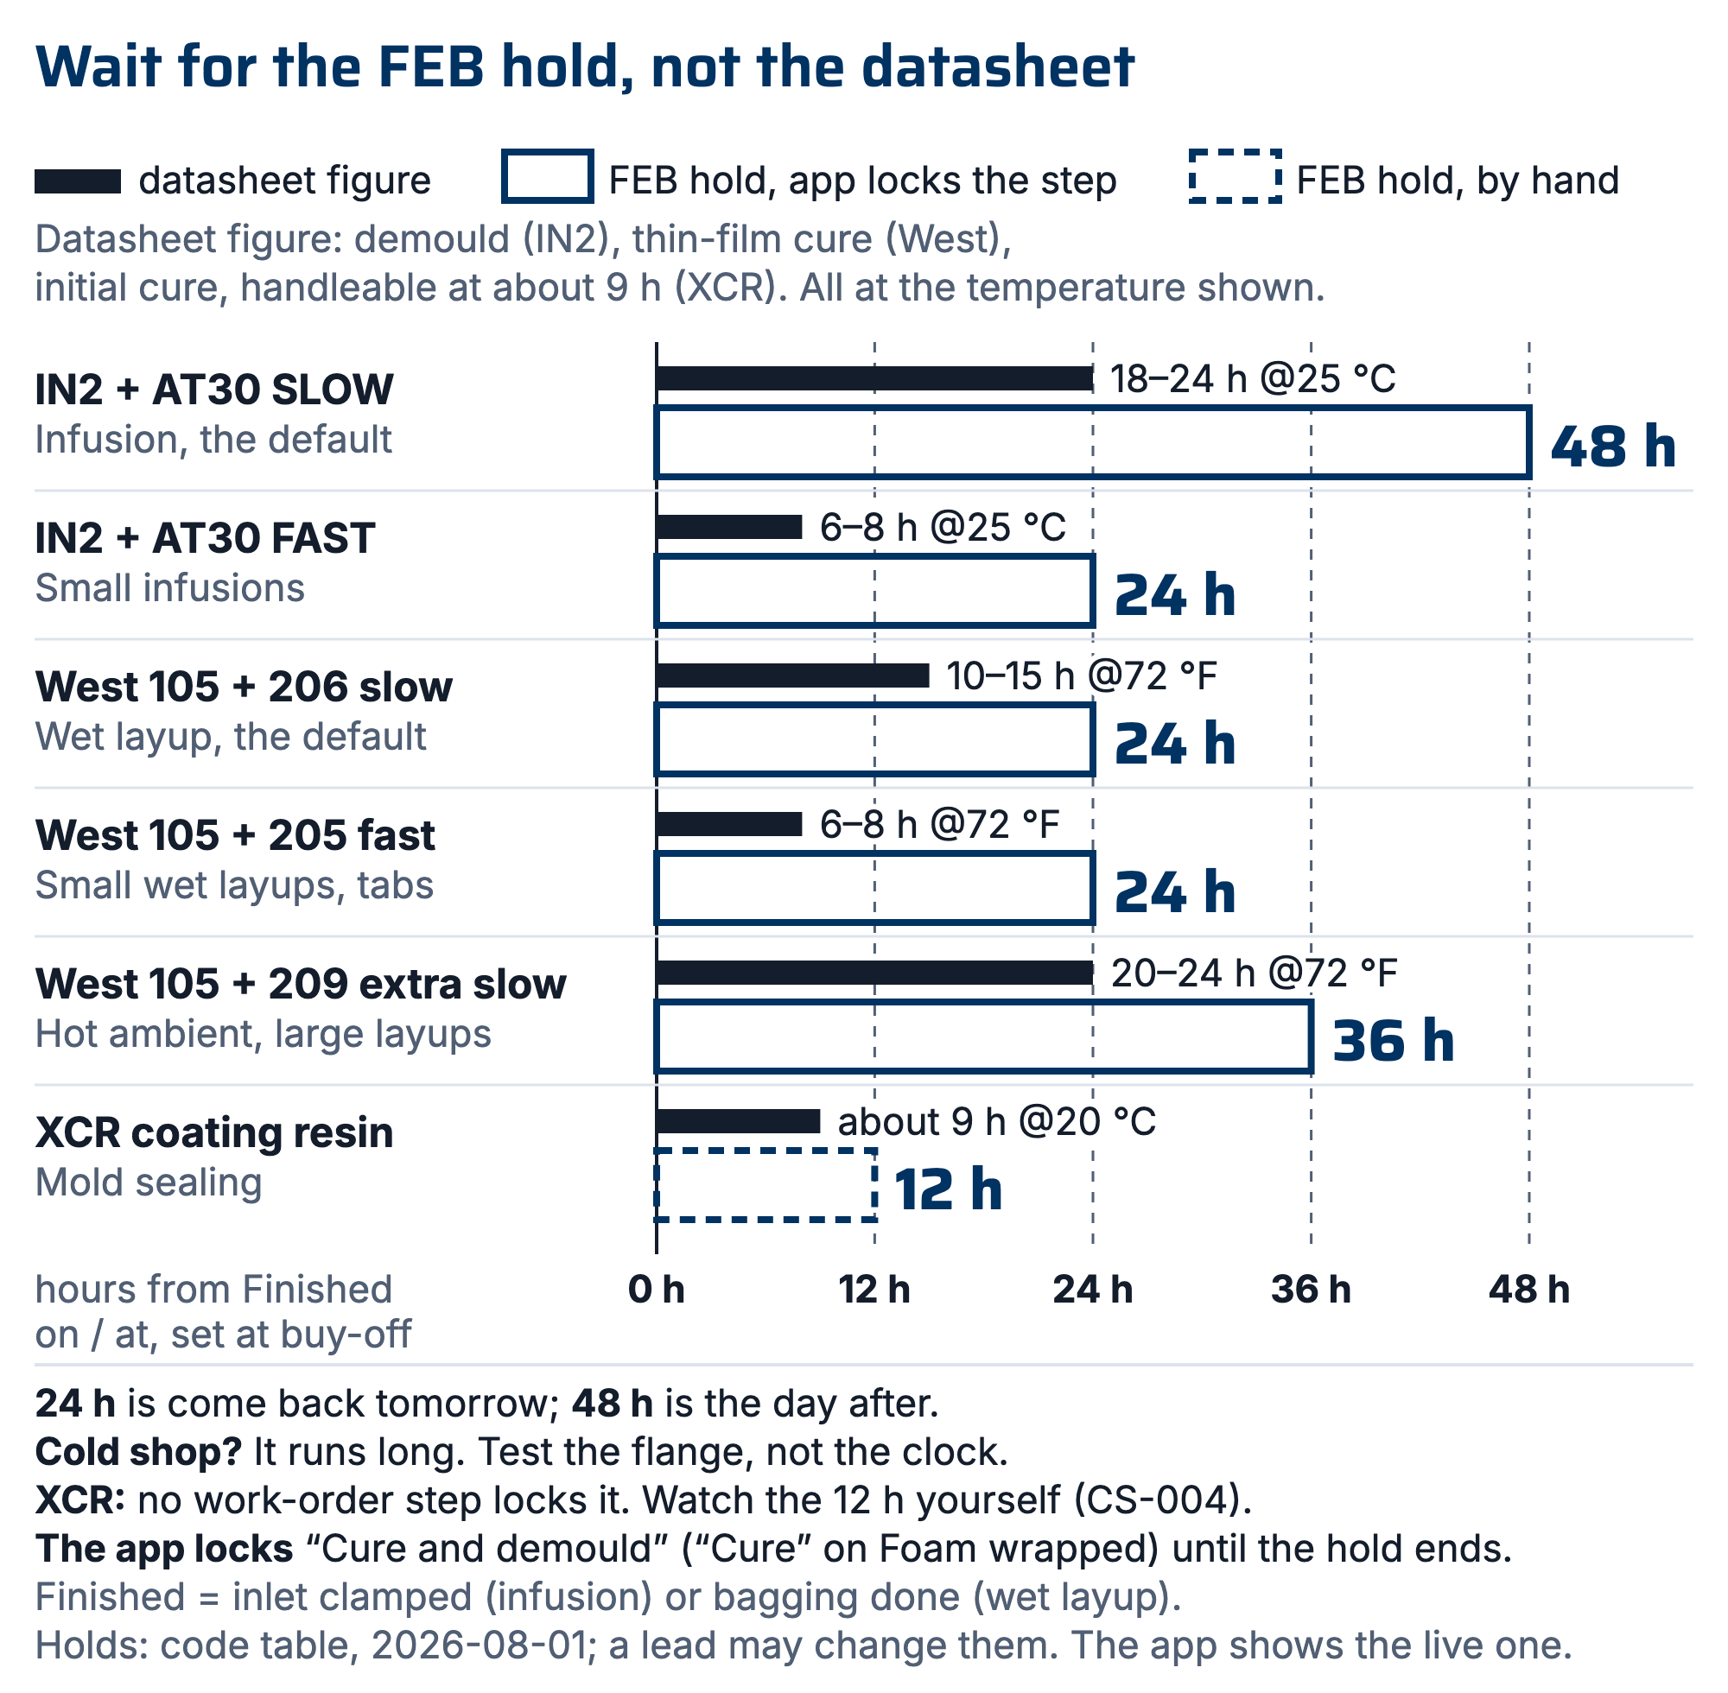
Figure 1. Datasheet cure figure (thin solid bar) against the FEB hold that governs (hollow bar), per system, on one time axis. The holds land on shift boundaries, which is why both FAST systems still hold 24 h.

What the app enforces. Signing the step that starts a cure ("Infuse", "Wet
layup and bag", "Wet layup over core") opens a buy-off that asks for "Resin
mixed", "Finished on" and "at", and "Shop temperature, °C (optional)". The next
step ("Cure and demould", or "Cure" on a Foam wrapped run) stays locked until
the FEB hold for that resin has run from the finish time. A member who tries to
sign it early is turned away. A lead may sign it early through "Demould early?",
which asks "Why are you demoulding early?" and writes the reason, the lead's
name and how many hours short it was to the work order's event log.
What the app does not lock. Mold sealing with XCR: no work-order step starts
an XCR cure, so its 12 h hold is watched by hand (CS-004 §7.3). Any cure
recorded as "Something else / not recorded": no resin means no hold. Retro
work orders, the records of SN5 runs, enforce nothing.
Changing a hold. The §5 table is the code table in
06 Composites App/app/resins.js at this revision, signed off 2026-08-01. The
live value is the app's. A lead may change a hold from the app, from a work
order whose hold for that resin is currently running: on the held step, press
"why N h?" to open "Why N hours?", press "Change this hold…", enter
"FEB hold (hours)", pick who signed it off and the date under "Signed off by",
and press "Save". The app refuses a hold below the datasheet figure and a hold
nobody signed off, and the change reaches every work order at once. "Revert to
the code table" in the same window undoes it. "Why N hours?" always shows the
hold in force and who signed it, and says when a lead set it from the app. A
lead who changes a hold shall open a revision of this standard within two weeks,
so the §5 table and the app agree again (CS-000 §2). A code-table hold shorter
than its datasheet figure fails the app's tests.

6. Safety: exotherm and sensitization (applies to every system)
Product | Hazard statements for people (SDS §2, R4; aquatic hazards left out)
IN2 resin | H315 skin irritation, H317 allergic skin reaction, H319 serious eye irritation, H360F may damage fertility
AT30 SLOW hardener | H302 harmful if swallowed, H314 severe skin burns and eye damage, H317, H318 serious eye damage
AT30 FAST hardener | H302, H314, H317, H318, H373 organ damage through repeated exposure, EUH071 corrosive to the respiratory tract
XCR resin | H302, H315, H317, H318, H341 suspected of causing genetic defects
XCR hardener | H302, H314, H317, H318
West 105 resin | H315, H317, H319
West 205 fast hardener | H302, H312 harmful in contact with skin, H314, H317, H318, H341, H373
West 206 slow hardener | H302, H314, H317, H318, H335 respiratory irritation
West 209 extra slow hardener | H302, H314, H317, H318, H335, H373

- Every resin and hardener here can make you allergic through the skin (H317). None is classified as a respiratory sensitizer (no SDS on file carries H334), but the XCR resin SDS §11.1 says it may be a respiratory tract sensitiser, so treat its vapour with the respirator rule below. Every hardener burns skin and can blind (H314, H318). PPE: nitrile gloves; safety glasses with side shields (EN 166); ventilation; wash skin with soap, not solvent.
- Respirator: for long or enclosed sessions, wear the team respirator with the stocked A + P100 cartridges (CS-011 §5); the A filter covers XCR, whose SDS asks for A1 (XCR SDS §8.2). For AT30 work you should use ABEK cartridges instead (AT30 SDS §8.2).
- Goggles: you should wear EN 166 goggles with side protection while pouring and mixing XCR (XCR SDS §8.2); until they are bought, safety glasses with side shields. ABEK cartridges and the goggles are on the purchase list.
- Resin or hardener in an eye: rinse with plenty of water, under the eyelids too, for at least 15 minutes, then get medical attention (R4: IN2 and AT30 SDS §4; West 205 SDS §4).
- Exotherm rules: mix the smallest batch that does the job; pour out of the pot promptly (mass concentrated in a cup accelerates); a warm cup = use immediately or spread thin; a hot/smoking cup = carry outside onto concrete and leave it. Do not bin, do not water-dilute indoors. Nothing goes in the trash until fully cured and cool.
- Never mix off-ratio to "speed up" or "slow down" cure; off-ratio = uncured sticky part. For IN2 you may blend AT30 FAST and SLOW instead, keeping the total at 100:30 by weight (R1). For West, no datasheet on file covers blending 205 and 206: do not blend them until one does.

7. Procedure
- Pick the system from §5 by process standard, with pot life to spare for the job.
Before you mix, you should check the expiry: the EXP date on the jug's label, or the Expires date on its lot page. Past it, ask a lead before it goes on a part.
⚠ 209 uses 3:1 pumps, not the 5:1 pumps used by 205/206. Check the pump head before stroking; this is the classic wrong-ratio trap.
- Weigh (scale, 1 g) or pump (West, full strokes only); record masses on the WO.
- Mix ≥2 min scraping walls/base (team margin over the IN2 TDS's 1 min; the XCR TDS asks for "a couple of minutes"); double-pot (transfer + remix, fresh stick) for anything going on a part surface.
- Forged CF mix math (R5): finished part mass ≈ cavity volume × 1.4 g/cc; fiber mass = 60% of that (pre-weigh it); resin to mix ≈ fiber mass × 1.25 (the excess squeezes out). Starving the mix made the first part brittle (failed bend test); don't eyeball it.
- Cure at ≥20 °C wherever possible; log ambient temp on the WO when it isn't (cold cures run long; see each TDS).
- Do not demould before the FEB hold in §5 has elapsed, counted from the end of the layup or infusion. The work order enforces this and records the resin, the finish time and the shop temperature; it is a lead call to go early, and the reason is logged.
Gel is not cure: fingernail-test the flange (§8) before you trust either the clock or the feel of the part.
When you sign the layup or infusion, pick the resin you actually mixed under "Resin mixed". Choose "Something else / not recorded" only for a resin not in §5; then write the resin in the step note, and its demould time is a lead's call.
- Leftovers: spread thin on scrap or leave outside to cure; label per CS-001.
- Cloudy or crystallized 105 after a cold spell: warm it to 125 °F and stir until clear before it goes in the pump (R3).
- After a long gap between uses, mix a small test batch to check the West pumps meter correctly and the batch cures, before a part depends on them (R3).

8. Quality checks / acceptance criteria
Check | Target | Method | Record where
Ratio | Weighed/pumped per §5, recorded | Scale/pump count | WO
No soft spots at demould | Fingernail test on flange/trim zone | Manual | WO qualityChecks
FEB hold observed | Elapsed before demould, or overridden with a logged reason | WO step buy-off | WO steps / event log

9. Records
Batch masses, system + hardener speed, ambient temp, cure duration: on every WO that consumes resin. The resin, the finish time and the shop temperature are captured by the work order at the layup or infusion buy-off, so this is a byproduct of running the job rather than a separate write-up.
The same buy-off records "Which lots went in" (Fabric, Resin, Hardener, pre-filled with the open lot; "I don't know / not recorded" is an honest answer) and "Materials used", pre-filled from the plan, one line per BOM item. Correct any line that differs; a blank means not measured.

